**Experiment 5**

**Objective: Write an IoT program in Tinkercad to develop a project on Environment applications using sensors and smart boards.**

**Components:Arduino,led,lcd display,gas sesnor,resistor,buzzer.**

**Circuit diagram:**

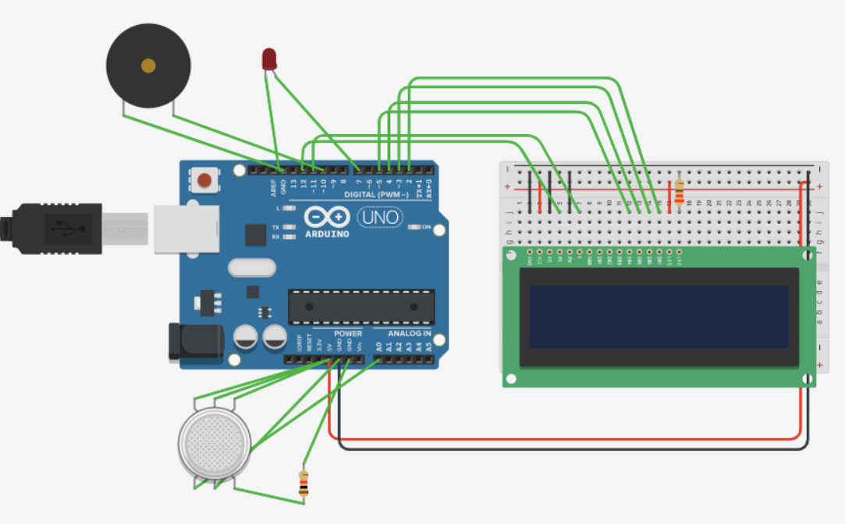

**Code:**

#include<LiquidCrystal.h>

int gas=A0;

int red=7;

LiquidCrystal lcd(12, 11, 5, 4, 3, 2);

void setup()

{

lcd.begin(16, 2);

pinMode(red,OUTPUT);

pinMode(10,OUTPUT);

pinMode(A0,INPUT);

Serial.begin(9600);

}

void loop()

{

lcd.setCursor(0,0);

lcd.print(gas);

gas=analogRead(A0);

if(gas>250){

digitalWrite(10,HIGH);

digitalWrite(red,HIGH);

delay(1000);

}

else

{

lcd.setCursor(0,0);

lcd.print(gas);

digitalWrite(red,LOW);

digitalWrite(10,LOW);

delay(1000); }

}

**Working principle**

A liquid crystal display or LCD draws its definition from its name itself. It is combination of two states of matter, the solid and the liquid. LCD uses a liquid crystal to produce a visible image,To connect LCD to the Arduino we need to import the LCD library.Where as gas sensor is a device which detects the presence or concentration of gasses  in the atmosphere.

In my code i have used smoke sensor and displayed it values on the screen.

Smart circuit designed to show information or the value directly on the lcd display once smoke is detected the light or the buzzer get turn on automatically and send the value to the lcd monitor directly.